

|  |  |
| --- | --- |
| **Hands-on Exercise No. 1**  **DigiSkills**  **2.0 Batch-05 Wordpress** | **Total Marks: 10**  **Due Date: 27/07/2023** |

**STUDENT NAME**

**Uzma Ejaz**

**Tasks:**

1. First, you need to install localhost Local by Flywheel.

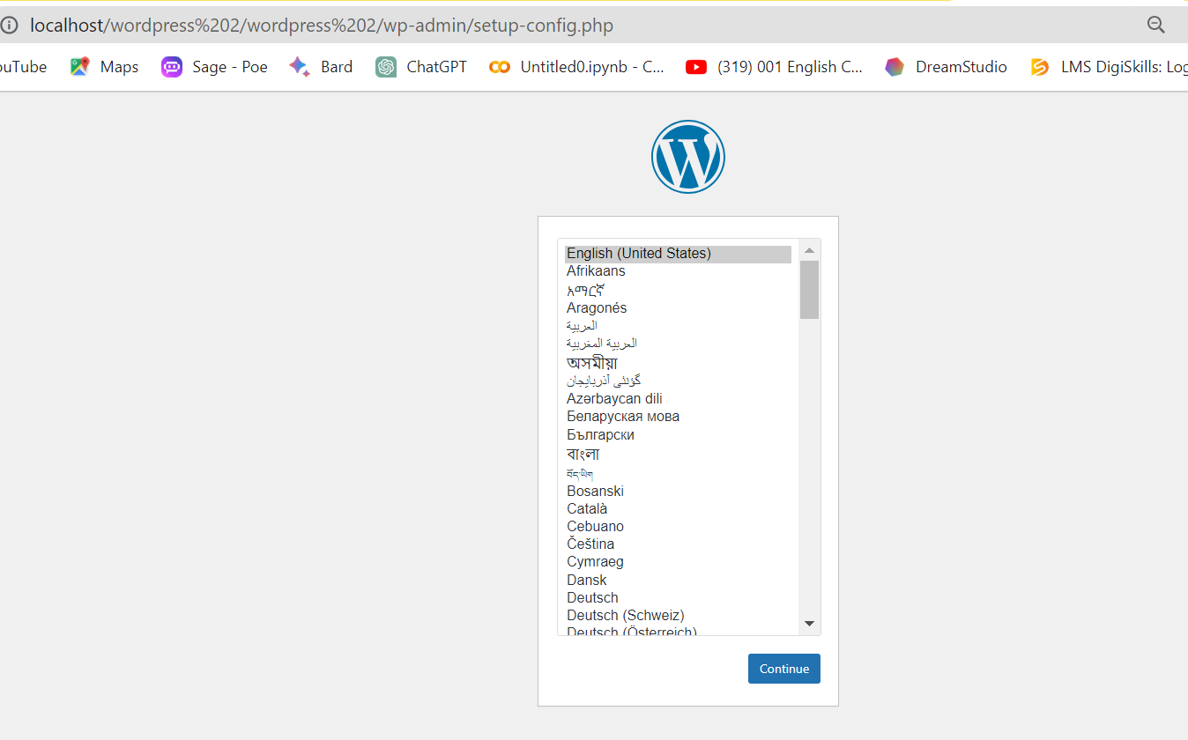

1. Install WordPress as explained in Lesson #8.

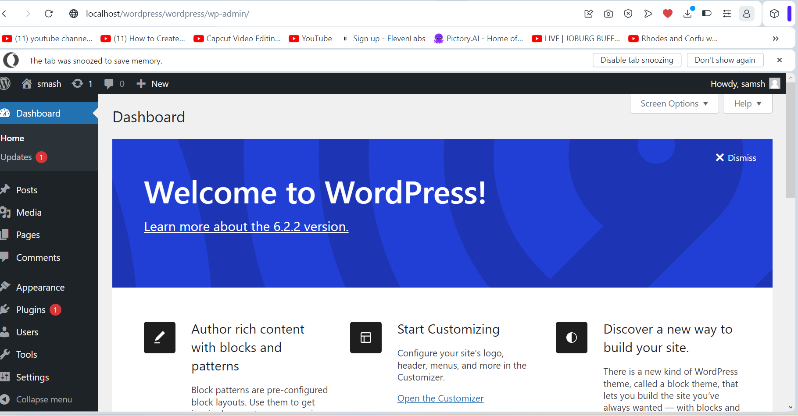

1. Create a Page.

